Y0:

Y1:

Y2:

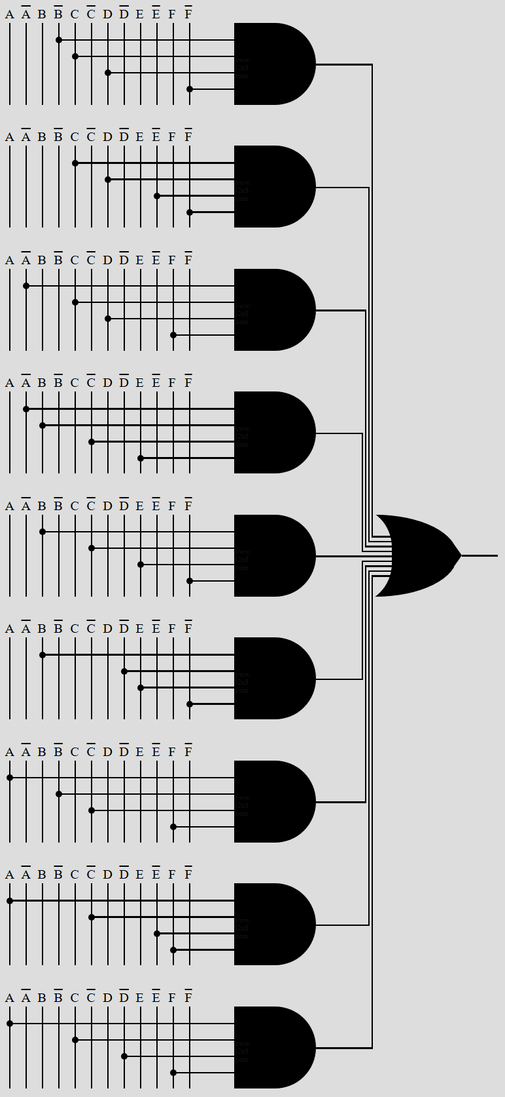

Y3:

Y4:

Y5:

